Building the e-commerce platform by implementing user authentication, shopping cart, and checkout functionality:

**User Authentication:**

* Implement user registration and login functionality.
* Use authentication libraries like Passport.js (for Node.js) or Devise (for Ruby on Rails) to handle user authentication.
* Secure user data and sessions using techniques like password hashing and JSON Web Tokens (JWT).
* Implement password reset functionality with email verification.

**HTML Code:**

<center>

    <h1>Artizan</h1>

    <p>

        Sign in to Arizan.com using your Artizan Account

    </p>

    <h2>

        Sign in

    </h2>

    <table border="1">

        <tr>

           <td> Email (phone for mobile accounts)

            </td>

        <tr>

          <td>  passord

            </td>

        </tr>

    </table>

    <h3>

        Sign in

    </h3>

    <table border="1">

        <tr>

           <td>Create a new Artizan account

            </td>

        </tr>

    </table>

    </center>

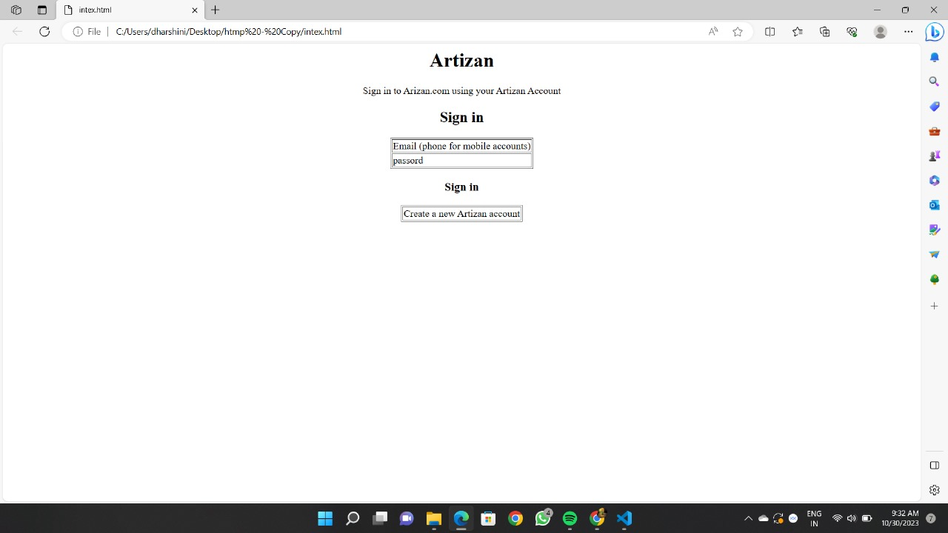**Output:**

**Shopping Cart:**

* Create a data structure to represent the shopping cart (e.g., a session or a database table).
* Allow users to add, update, and remove items from their cart.
* Calculate the total cost of items in the cart.
* Use cookies or session management to associate a cart with a user.

**HTML Code:**

<!DOCTYPE html>

<html lang="en">

<head>

    <meta charset="UTF-8">

    <meta name="viewport" content="width=device-width, initial-scale=1.0">

    <title>Artizan</title>

    <link rel="stylesheet" href="style.css">

</head>

<body>

    <div class="header">

      <nav>

        <h1>Artizan</h1>

        <ul>

            <li>Home|</li>

            <li>About us|</li>

            <li>Contact us</li>

        </ul>

      </nav>

    </div>

    <div class="searchbar">

        <input placeholder="seach">

    </div>

    <div class="products">

        <div class="box">

       <img src="images.jpeg">

       <p>Black Forum Baby Reborn Toddler Baby Dolls Silicone Full Body girl22 inch Long Hair Anatomically Correct Waterproof Dolls Reborn Pink Dress Birthday Gift Set for Girls</p>

    </div>

</div>

    <div class="about">

        <h1 style="text-align: center;">Thank You</h1>

        </div>

</body>

</html>

**CSS Code:**

*{

    margin:0;

    padding:0;

}

nav{

    background-color: black;

    color: white;

}

li,h1,ul{

    display:inline;

}

ul{

    margin-left: 60%;

}

li{

    color: gray;

}

li:hover{

    color: white;

    cursor: pointer;

}

input{

    width: 60%;

    padding: 15px;

}

.searchbar{

    padding:50px;

    text-align: center;

}

.box{

    border-color: black;

    border-width: 2px;

    border-style: solid;

    display: inline-block;

    width: 220px;

}

.products{

    text-align: center;

}

.about{

    text-align: center;

    margin-top: 20px;

}

**Output:**

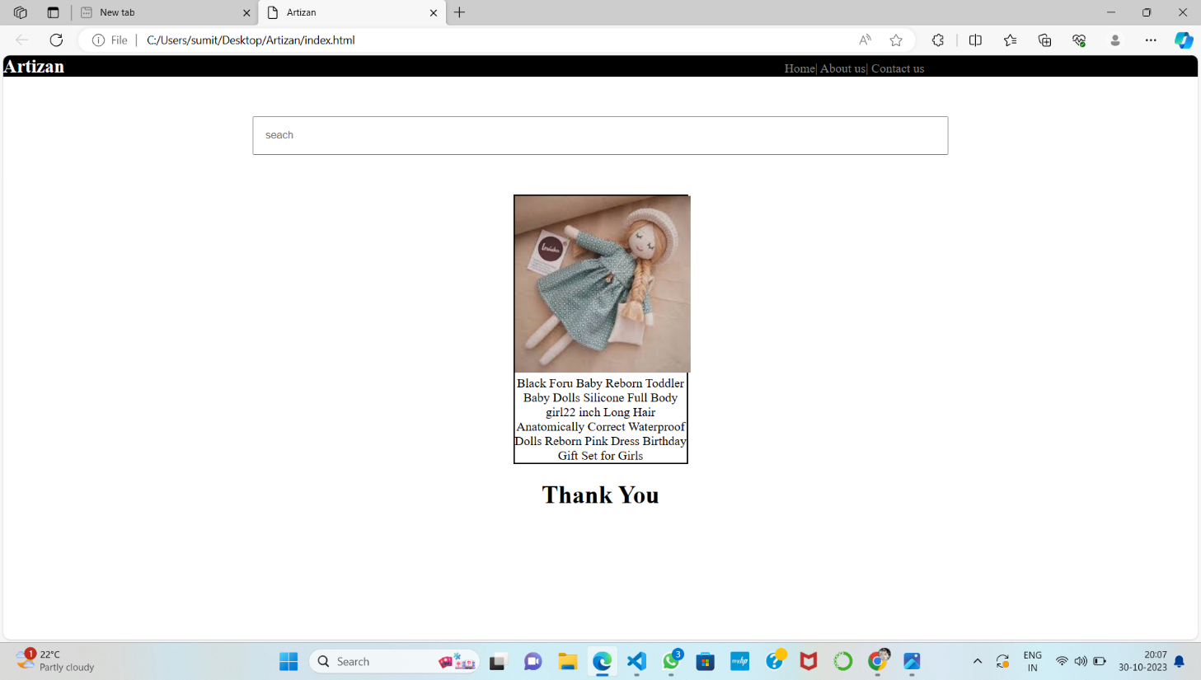

**Checkout Functionality:**

* Create a secure payment gateway integration (e.g., Stripe, PayPal, or other preferred providers).
* Allow users to enter shipping and billing information.
* Implement order confirmation and receipt generation.
* Handle order fulfilment, including inventory management and order status updates.

It's essential to plan meticulously, invest in robust security measures, and continuously adapt to meet the changing needs and expectations of your users.